**Outstanding ETS Participants**

**2020**

Landon Morris was nominated by the faculty and staff of Corner Middle School as their Outstanding ETS Student of the Year because he is a leader in the classroom with academic assignments. He is helpful to teachers as well as his fellow peers, and he is a role model for students in his grade and below. His counselor, Chloe Whitaker, stated it best, “Personally, I believe him to be a wonderful, well-mannered kid that easily deserves this award.”

Anna Harris was nominated by the faculty and staff of Corner High School as their Outstanding ETS Student of the Year because she happily spends time volunteering and serving others. She is a lifelong learner and always takes advantage of opportunities to learn. Lastly, she is an inspiration and positive influence on others.

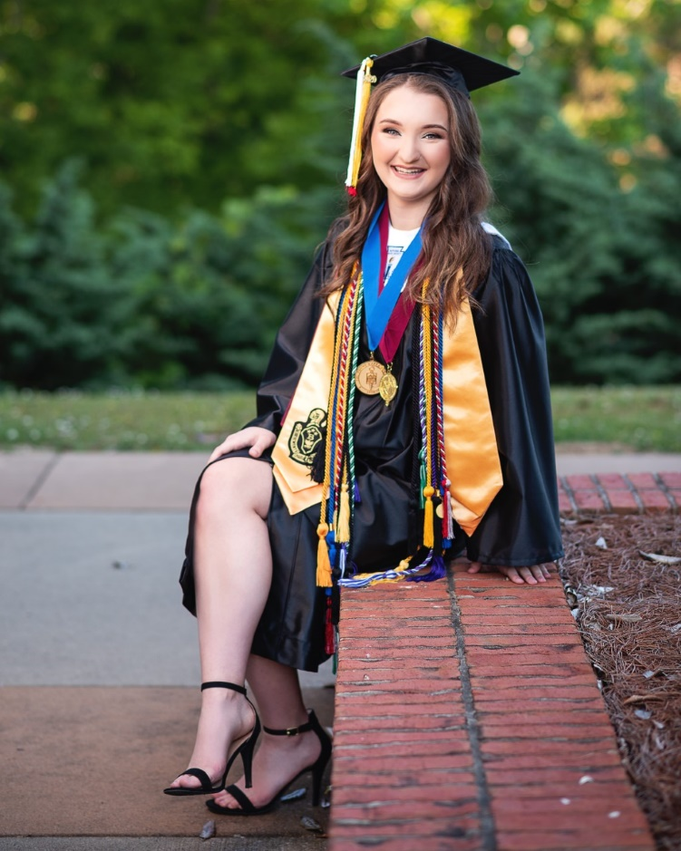

Zoey Nabors was nominated by the faculty and staff of Oak Grove High School as their Outstanding ETS Student of the Year because she serves as the Treasurer for the Senior Class and DECA. Zoey actively participates in SGA, ETS, YLDP, Math Club, Future Problem Solvers, and The National Honor Society. Zoey has a lot of talent and determination. She plans to attend UA in the fall and major in Elementary Education and hopes to earn a spot on the Million Dollar Band Color Guard.

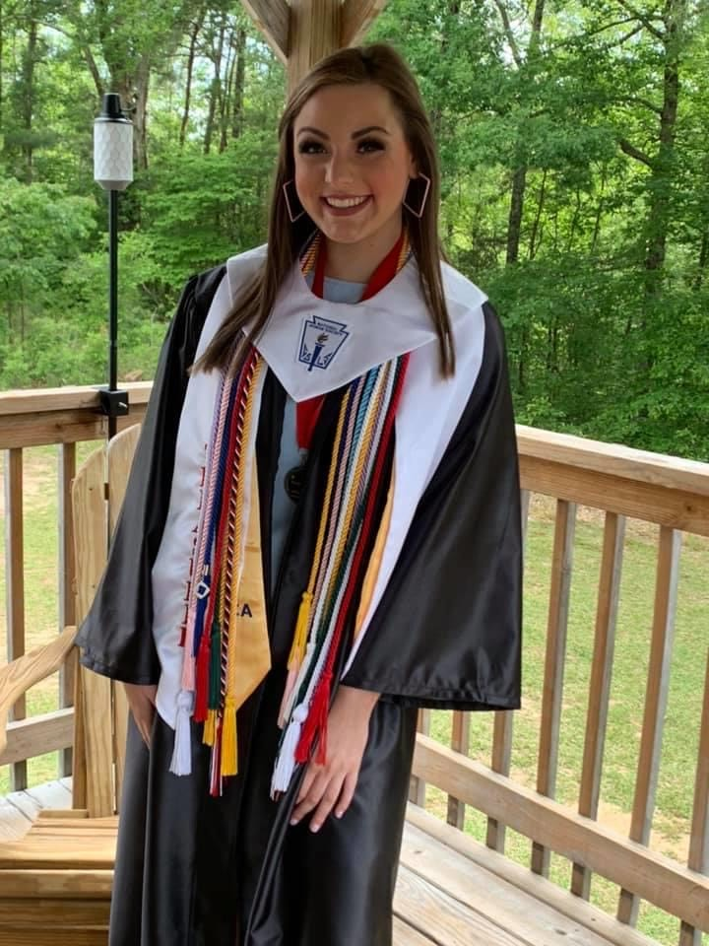

Toby Parker was nominated by the faculty and staff of Minor High School as their Outstanding ETS Student of the Year because he is always willing to go above and beyond to help someone out. He works hard academically to maintain an A/B average. Toby is a member of the Minor High School Band and is a positive role model among his peers.

Lydia Morrison was nominated by the faculty and staff of Jasper High School as their Outstanding ETS Student of the Year because she is a very determined person. She loves to read! She almost always has a book with her. Lydia plans to pursue a career in Forensic Accounting.

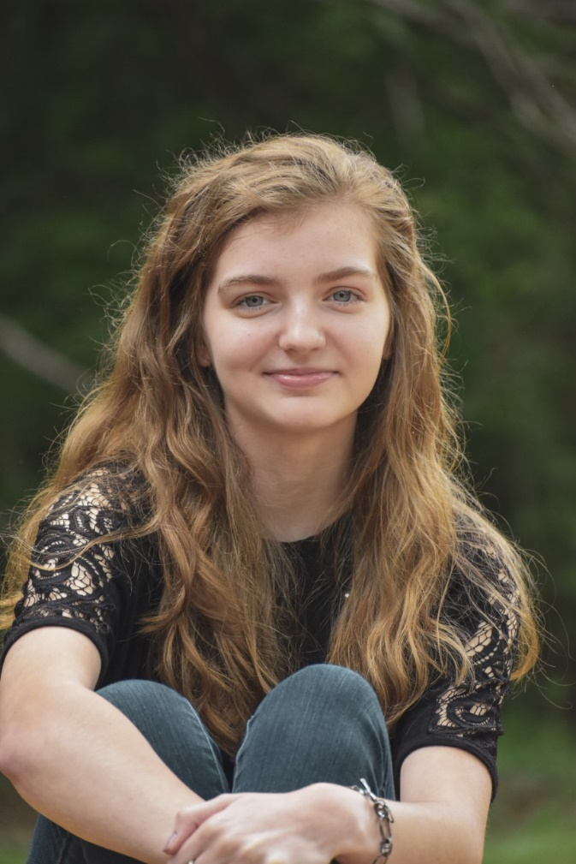

Skylar Mosher, Winston County High School, is involved in the ETS program and has been since 9th grade when the program first began at WCHS. Skylar has benefitted from the college and career development programs. She has been very involved in the various events and programs hosted by ETS over the last four years. Skylar received a merit-based scholarship to Bevill State Community College AND to UAB. Congratulations, and BEST WISHES to Skylar Mosher, an excellent example of what Educational Talent Search is all about.

Cheyanne Barber, Fayette High School, has been nominated and selected by not only the staff at ETS, but also her high school counselor as the ETS Outstanding Participant for the 2019-2020 school year. Cheyanne graduates from Fayette this year having taken the most rigorous academic courses offered at FCHS. She is not only respected by her peers and teachers, she also is highly esteemed by the ETS staff. Cheyanne had perfect attendance over the four years in the program. She also was eager to participate in events and workshops, bootcamps, and FAFSA assistance. Cheyanne will be very successful as she continues her post-secondary journey because she took advantage of all that Educational Talent Search has to offer.

Riley Thacker, Lynn High School, graduated with many honors and received numerous scholarships. She was nominated for the FOX6 Rising Star award. Riley was the class secretary, a mentor in the morning school teacher assistant program, and president of DECA. She was active in BETA Club as well as National Honor Society and was the cheer squad co-captain. She plans to finish an associate’s degree in applied science at Bevill State Community College where she has already obtained numerous hours of dual enrollment credit. She will then transfer to UNA where she plans to finish a degree in business administration. A member of ETS since 11th grade, Riley embodies what we hope all ETS participants will strive to attain: academic excellence, high moral character, and excellent leadership abilities among her peers.

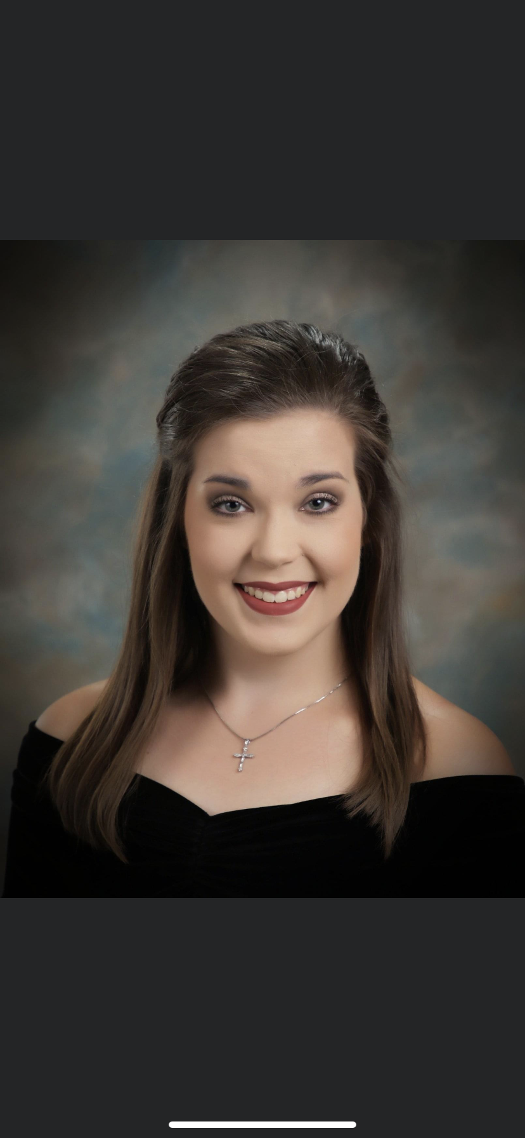

Emily Huang, Fayette Middle School, has been nominated and selected as an Outstanding ETS Participant for the 2019-2020 school year. Emily is the ideal student. She has the reputation among the faculty and staff as being in class every day, being prepared to work, and doing so with a cheerful attitude. She is currently ranked number one in her class with a 99.85 overall GPA. She plays oboe in the middle school band and was selected as a member of the District Honor Band. She is a member of the high school tennis team. To her classmates, Emily is kind and considered a good friend. She exhibits the academic excellence and high moral character for which all Educational Talent Search students strive.

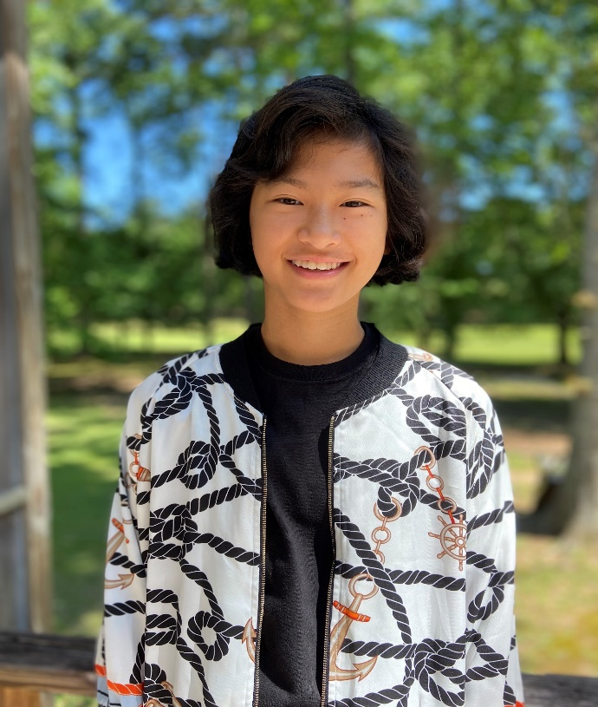

Alyssa Dye, Double Springs Middle School, has been selected as one of the Outstanding ETS Participants of the Year. She is, according to her counselor, a “wonderful young lady. We are so proud of her!” Alyssa is goal-driven, diligent, courteous, and honest. She shows leadership by her strong personality, her ability to build relationships, communicate, and motivate others toward a common goal. She truly embraces learning and strives for academic excellence. Her most captivating quality is her high moral character. She displays integrity in all that she does, and her empathy for others is also evident. Alyssa is a wonderful student and role model. Congratulations to Alyssa Dye! The BSCC-Fayette Educational Talent Search program is proud of you as well.

